3.23: a) With 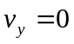 in Eq. (3.17), solving for t and substituting into Eq. (3.18) gives
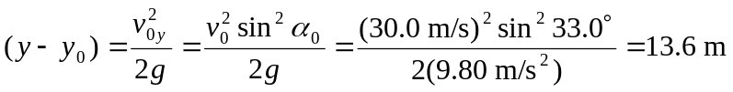

b) Rather than solving a quadratic, the above height may be used to find the time the rock takes to fall from its greatest height to the ground, and hence the vertical component of velocity, , and so the speed of the rock is.
c) The time the rock is in the air is given by the change in the vertical component of velocity divided by the acceleration –g; the distance is the constant horizontal component of velocity multiplied by this time, or
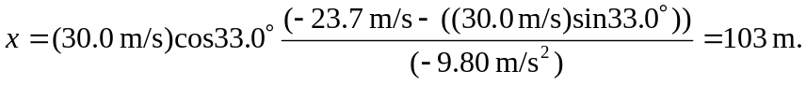
d)
